**PURBANCHAL UNIVERSITY**



**DEPARTMENT OF COMPUTER ENGINEERING**

**KHWOPA ENGINEERING COLLEGE  
LIBALI-2, BHAKTAPUR**

**A MID-TERM REPORT**

**ON**

**FOOD FOR NEEDY**

Project work submitted in partial fulfillment of requirements for the award of the degree of Bachelor of Engineering in Computer Engineering (Fifth Semester)

**SUBMITTED BY**

Niru Kumari Mishra (740325)

Rabin Phaiju (740329)

Rodip Duwal (740334)

Roshan Dumaru (740335)

**UNDER THE GUIDENCE OF**

Er. Reena Manandhar

10 March 2020

|  |  |  |
| --- | --- | --- |
| **Chapter** | **Title** | **Page** |
|  | Title Page |  |
|  | Table of Contents |  |
|  | Acknowledgement |  |
|  | List of Figures |  |
|  | List of Abbreviation |  |

**TABLE OF CONTENTS**

|  |  |  |
| --- | --- | --- |
| 1 | Introduction | 1 |
| 1.1 | Background | 1 |
| 1.2 | Statement of Problems | 2 |
| 1.3 | Objectives | 2 |
| 1.4 | Scopes | 2 |

|  |  |  |
| --- | --- | --- |
| 2 | Literature Review | 3 |
|  |  |  |
|  |  |  |
| 3 | Methodology | 4 |
| 3.1 | Background | 4 |
| 3.2 | Accomplished Work | 4 |
| 3.3 | Work to be done | 6 |
| 3.4 | Block Diagram | 7 |
| 3.5 | Tools and platform | 7 |
|  |  |  |
|  |  |  |
| 6 | References | 8 |
|  |  |  |

**ACKNOWLEDGEMENT**

We are extremely grateful to Department of Computer Engineering, Khwopa Engineering College for providing us the opportunity to work on the project named **“Food for Needy”** to explore our abilities and knowledge in the field of computing.

We hope that our proposal will be approved and we will be allowed to do this project from the Department of Computer Engineering.

**Project Team Members:**

Niru Kumari Mishra (740325)

Rabin Phaiju (740329)

Rodip Duwal (740334)

Roshan Dumaru (740335)

**LIST OF FIGURES**

|  |  |  |
| --- | --- | --- |
| **Fig no.** | **Title** | **Page** |
| 4.1 | Generic Model of “Food for Needy” | 5 |

**LIST OF ABBREVIATION**

|  |  |  |
| --- | --- | --- |
| **S.N.** | **Short Form** | **Full Form** |
| 1 | etc. | Etcetera |
| 2 | JS | JavaScript |
| 3 | MYSQL | Structured Query Language |
| 4 | No. | Number |
| 5 | PHP | PHP: Hypertext Preprocessor |
| 6 | S.N. | Serial Number |

**CHAPTER 1**

**INTRODUCTION**

**1.1 Background:**

Nothing brings people together like a generous spread of delicious food. It’s the universal unifier. Food serves as a cultural marker, attends every milestone and celebration, and can be dressed up or down. Food is where the heart is. Below you’ll find a collection of wise, inspirational and humorous food quotes, sayings and proverbs. Food is any substance consumed to provide nutritional support for an organism. Food waste is the disrespectful on so many levels to hungry, to the people that spends their times cooking, to our natural resource, yet it is a practice that is generally and accepted and makes fighting it so challenging.

Food rescue, also called food recovery or food salvage, is the practice of gleaning edible food that would otherwise go to waste from places such as restaurants, grocery stores, produce markets, or dining facilities and distributing it to local emergency food programs. At glance, food waste doesn’t seem like a big problem. However, if we look deep into it, wasting food has caused some serious damages. The number of food waste has increased quite significantly since 1976. In the world, 13 billion of food go to waste each year. Meanwhile, in the US, 40% of food produced never gets eaten, meaning that 165 billion dollars’ worth of food is thrown away every year. It could fill 730 football stadiums every year! Seeing how many people in the world, or even within a particular country, live in hunger and malnutrition, this situation is inequitable. Within this, there are many disadvantages of food waste, this article with cover some of those including, environmental issues, morally unacceptable in the case of fighting hunger, and the way of labor, time, as well as natural resources.

Food for Needy is a platform to fill the appetite for hunger people. It is a website to resolve the wastage of food in a useful way. Every day the people are wasting lots of foods. Internet has become an ocean of information related to every aspect, which is extensive in the world. The main purpose of this website is to fill the hungry stomach. This website will act as an active platform where many restaurants, grocery stores, produce markets etc. will update the information of excess food to the website and thereby many food organizations and individuals will come to know about the availability of food through this website and hence, making all stomach happy.

**1.2 Statement of problem:**

Through this project, we are trying to provide food recovery ways, that can eliminate hunger and food waste.

Previously in many projects, a proper bridge was not established between the needy people and the excess food by restaurants, grocery stores, produce markets etc. The previous projects lacked proper display of the category of food item, cook time that were updated by the restaurants, grocery stores, produce markets etc.

**1.3 Objectives**

The main objective of this project is to craft an effective public awareness and to feed needy.

**1.5 Scope**

The scope of this project is to host in web. The project will be designed inconsideration for the needy people. It will be very easy, reliable and effective way to feed the hungry stomach.

**CHAPTER 2**

**LITERATURE REVIEW**

We have referred some other similar website and they were having the problem in maintaining the quantity of the food, expiry and other details of the food. Thus, our purposed system maintains the details of the above problems. [1]

The other websites were not having the waste_food_id and the user_id. This project will be made in consideration to the above problem. There was no categorization of foods.[2]

Thus, our project “Food For Needy” has lots of similar features like login page, user page, admin page etc. Including that we have the features lacked in previous projects like categorization of food items, message between donor and receiver etc.

**CHAPTER 3**

**METHODOLOGY**

**3.1 Background**

Food for Needy is web-based online platform to feed the needy people. This project is created to manage wastage of food in useful way. Here, This site tends to reduce the wastage of food problem through online I.e. If anyone have the foods to offer, they can enter the food quantity details and their address. The donors and the receiver can create an account & whenever they are have the food to offer, they can login and give request to the admin. And the admin also maintains the details of all the donors, receiver and the food organizations who are going to feed the needy with the help of our website.

For the development of the such site we collected required information from different site such as Groliste, Food Rescue, Food Tank etc. & we have used markup language such as HTML ,scripting language such as JS and style sheet language such as CSS etc.

**3.2 Accomplished Work**

Here we have our up-to date result listed below:

**Front End**

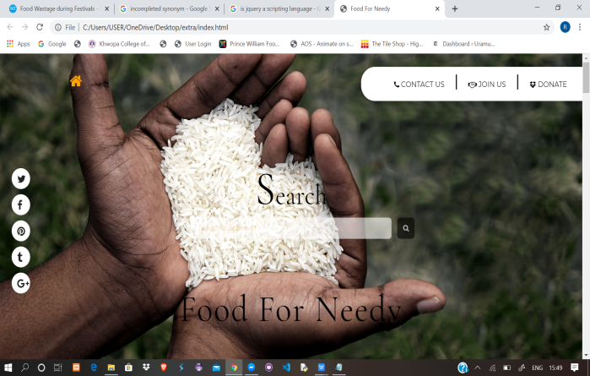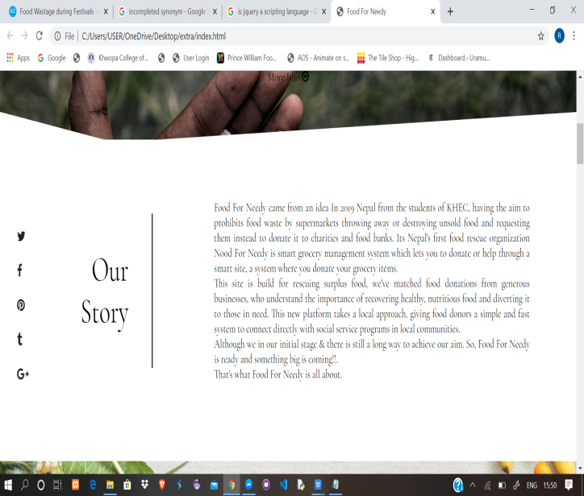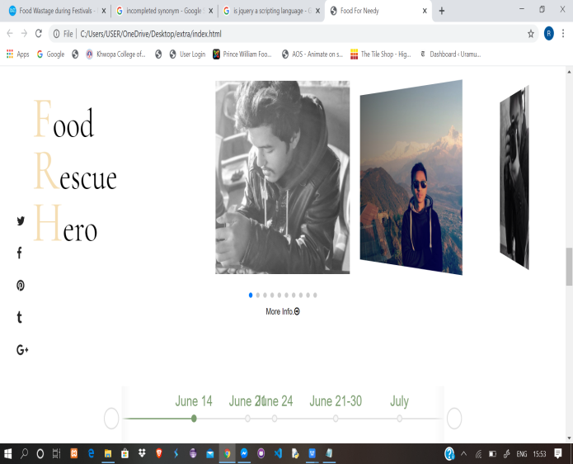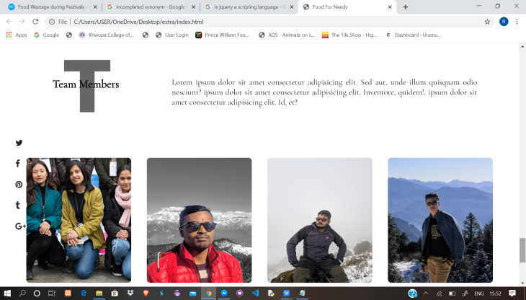

Fig 3.2.1

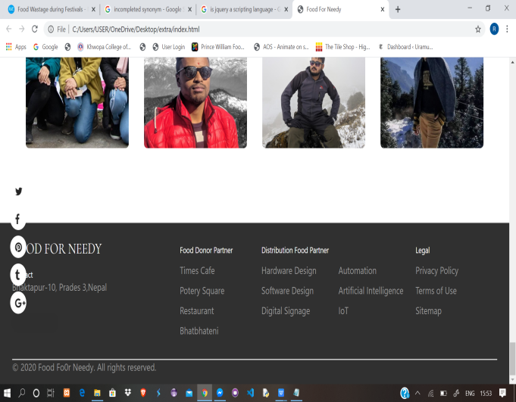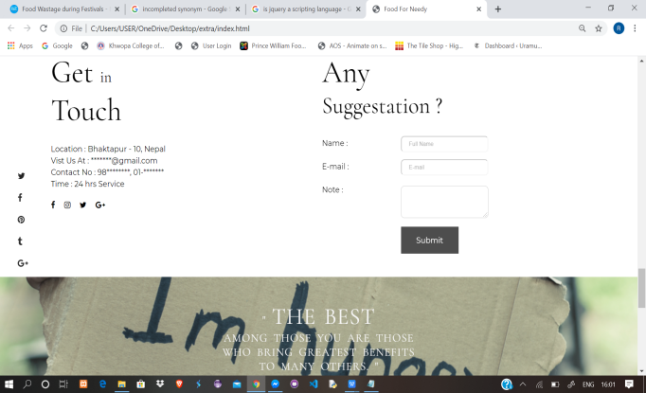

This is the front page of our project displaying services/information about our website.

**Data Base**

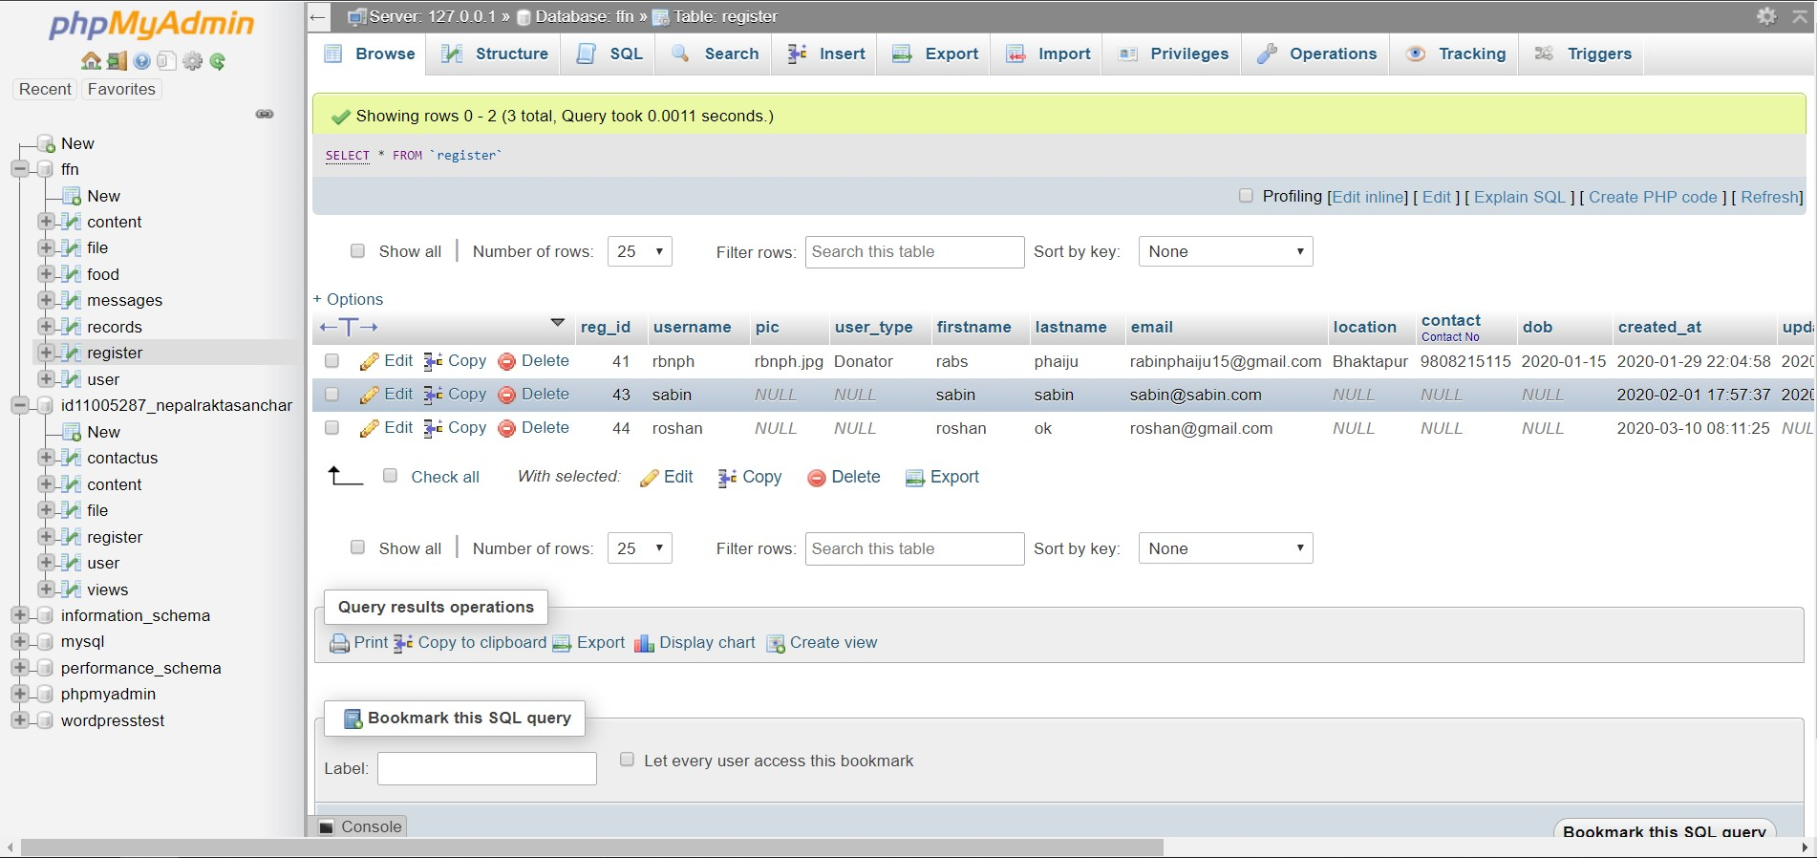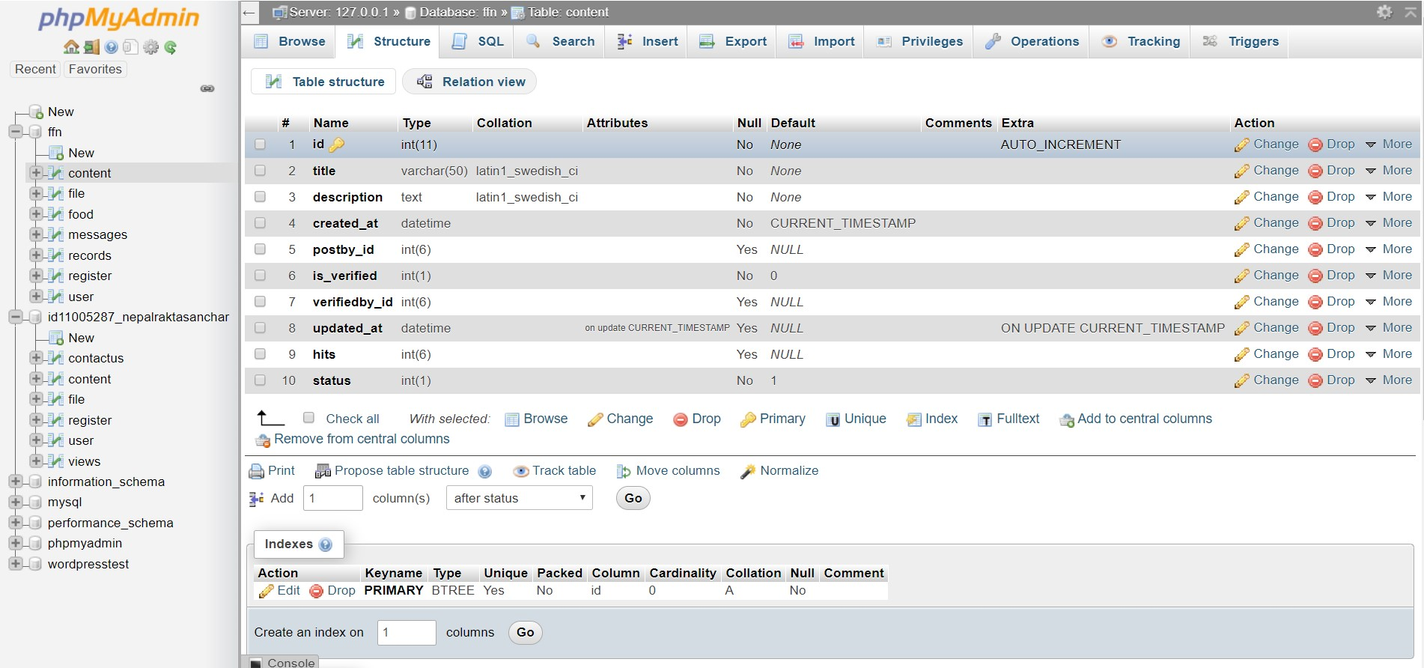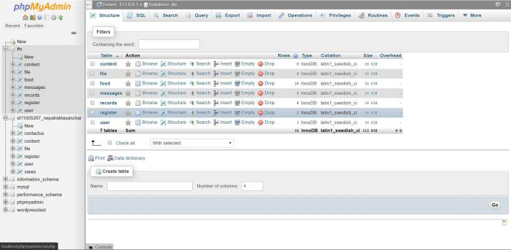

Fig 3.2.2

This is our database system of our project.

**User Login**

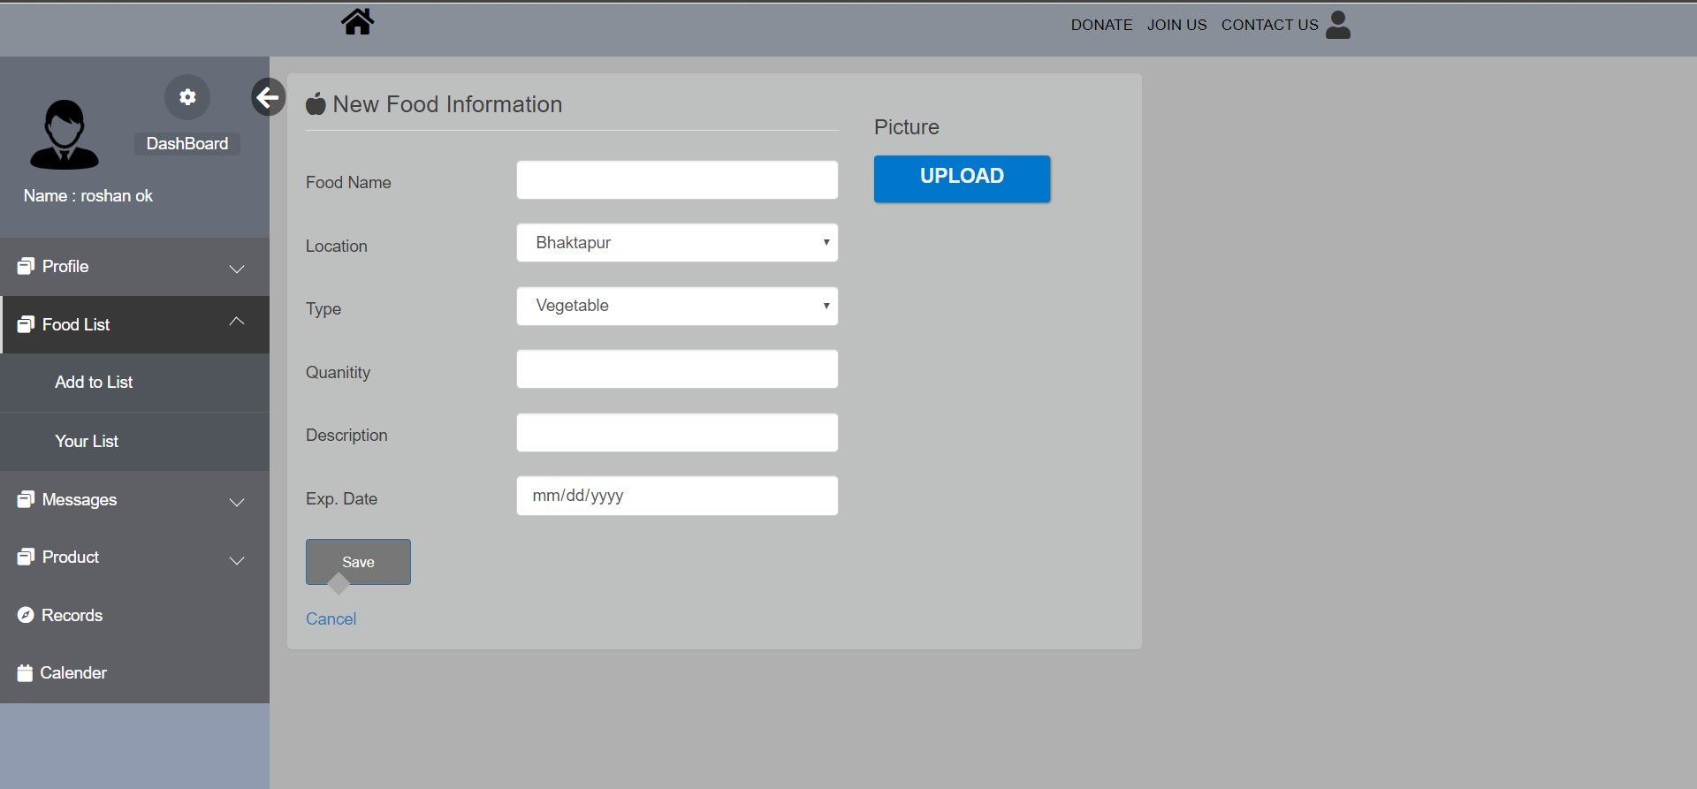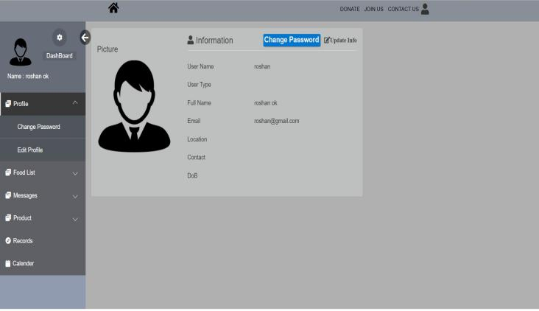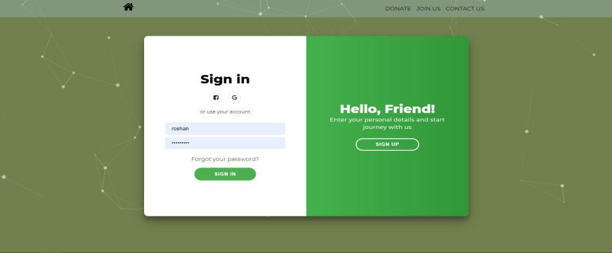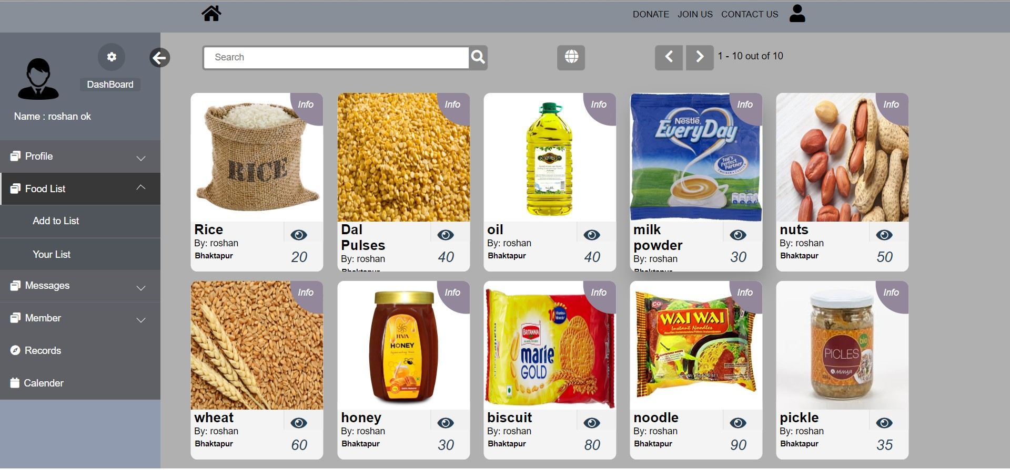

Fig 3.2.3

This is user-login page of our website. Here we can view and update user information. The add food page contain adding new items for the website. In view food, user can view item that they added and in index page all the available items are viewed.

In login user have to provide username or email and password to login. User have to provide username,name, email and password (must contain capital letter,number and total 8 digits).

**3.3 Works to be accomplished**

Some of the works are still to be done in order to complete our project which are:

* Improvement in Front End (Adding Splash Screen, Scroll up).
* Improve Back End Features such as adding category.
* Adding direct message features with donor and receiver

**3.4 Block Diagram**

Fig 3.2.4: Block diagram of Food For Needy

Login

Provider

Receiver

Name

Address

Phone Number

E-mail

Firm Name

**3.6 Tools and Platforms**

During the development of the project, the tools and platforms that we used for coding and testing the project are:

1. Visual Studio

2. Google Chrome

3. Brave

4. Git Hub

5. Apache

6. Sub-line Text

**CHAPTER 4**

**REFERENCES**

[1] www.groliste.com/groliste.com [11/12/2019]

[2] www.foodtank.com/about.html [11/13/2019]